TOKENIZING TELECOM SERVICES FROM INDIAN TELECOM GIANTS

**Problem Statement**

As of 31st March 2019, India is world’s second largest telecommunications market, with total subscriber base of 1,183.51 million and Over the next five years, it will rise in mobile-phone penetration and decline in data costs will add 500 million new internet users in India.

National Digital Communications Policy was unveiled by the Govt. of India in September 2018 which aims to attract US$100 billion worth of investments and generate 4 million jobs in the sector by 2022.

Despite the above mentioned glossy figures and many other positive elements in patches like these, the financial state of the telecom market in India is in dire straits.

As of 31st March 2019, the total debt of all Indian telecom companies was Rs4.3 lac crore. Share of the 3 major telcos Reliance Jio, Bharti Airtel & Vodafone Idea is at Rs 67000 crore, Rs 102903 crore & Rs. 118390 crore respectively. Though these debt figures slightly came down in the Q1FY20 for Airtel & Vodafone because of the fund rising (Rs 25000 crore each), yet the fact that reduction in debt is lower than the funds raised indicates the continuous cash burn in the industry.

Tokenization of some or all of the offerings from telecom companies with support from regulatory authorities will go a long way in building a trustworthy and resilient telecom ecosystem where the consumer will not hesitate to spend more and spend for long term services. A blockchain token based transparent system will definitely enhance values and diversify the market as more creative and innovative way of spending and investment will be explored and utilized.

**Business Rationale**

The current Indian telecom market needs tectonic shifts in their business model which is many ways clinging to the traditional way within a circumference of just crossing their rivals. A tit-for-tat approach of the companies towards each other lack a collective effort to move the industry in a positive direction, the result of which is in front of us. The lack of trust in the companies among the customers and availability of only a few type of provided services has limited the market growth for quite some time now.

Here, we propose a solution where the telecom giants like Airtel, Jio etc. tokenize their traditional services like Voice, Data, Value Added Services(VAS) etc. & bring in new tokenized OTT services like financial helpline, customer-to-customer consultations (e.g. Doctor-Patient, Youtube Pundit-New You-tuber, Beautician-Customer etc.) etc. A tokenized system which gives the user flexibility to use the service the way they want and provide transparency regarding their spendings will encourage them to take higher rate plans. This will increase average revenue per user (ARPU) which in India is currently one of the lowest in the world.

A demand based fluctuation of ‘token-required’ (cost) for utilizing services like voice, data etc. will revolutionize the industry and balance the so far highly asymmetrical balancing of loads on the operational units. Critical services like international roaming etc. will be used more frequently which will contribute to growth in revenue.

With tokenization, loyalty & reward systems will be more efficient. It will fast and the form of reward will be same that of the expenditure(token).  Peer-to-peer data transfer, service transfer etc. will be used more frequently when the transactions become faster and transparent.

India has not yet exhausted potential returns from the telecom sector. In fact, the second round of dividends may be round the corner from the data economy and 5G.

**FAQ:**

1.What is AionCoin Token?

:: AionCoin is a utility token can be used to utilize services from Bharti AirTel.

2.Who are all benefited

:: All Airtel Service consumer will be benefited from it. The telecom company itself will be benefited in many ways.

3.How customer is benefited

:: Customers will be able to utilize the services in a more flexible way. The transparency of their expenditure also will be create a more trusted bond with the company.

4.What kind of privacy rules we maintain

:: The privacy of b2c and b2b customers will be more secure.

5.How rewards works?

:: Rewards will be there for as part of loyalty scheme and also for the referral program.

6.What is the Min Token purchase?

:: Minimum token purchase is a lot of 100 AionCoin token.

7.What are the payment methods?

:: PoS, UPI, Internet Banking.

**Value Metrics**:

Token:: AionCoin

Value:: 1 AionCoin = Rs0.01

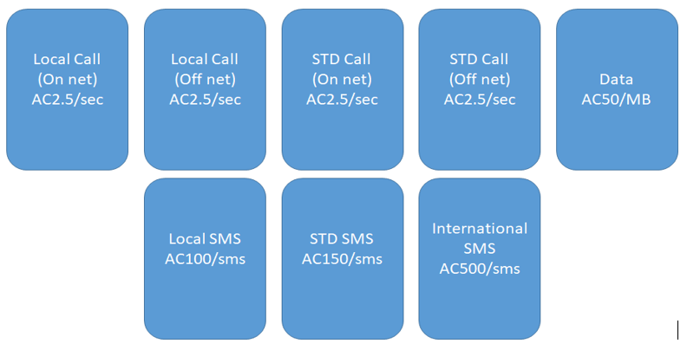

* Pre-sale length should be four weeks.
* Start price of AC at Pre-Sale is expected to be ₹0.006 (40% discount), by end of pre-sale it should grow to ₹0.008 (20% discount).
* Start price of AC token at Pre-ICO is expected to be ₹0.009 (10%). Later at ICO, the price should grow to the full price of ₹0.01.
* Subscriber has to buy minimum 100 tokens.

Community Adoption

•Join the first India’s First Blockchain Mobile Operator with Token holder rewards. We guarantee the Privacy aware Immutable log of Operations.

•We will be planning the marketing in such a way to educate the community with the benefits of Tele Tokens and guarantee of their data privacy. Customers can avoid the paperwork upon registration. Faster Signup is possible.

•User dashboard is the key where functionality of the project is interconnected via APIs, external integration service, and payment gateways, letting members manage their SIM cards and telecom features, make deposits and payouts, purchase and stack TELE tokens, and so on.

•If customers interested, they can buy the SIM card also from the same registration. In order to top up the customer will need to make a deposit and then transfer the required amount of funds to their SIM card balance.